Special Educational Needs and Disabilities (SEND) Information Report

Greatstone Primary School

Inclusion Team
SEND Governor:
Caroline Allen and Glynn Hukins
SENCO/SEND Team:
Fiona Roberts
Contact No. 01797 363916
Inclusion Team:
Fiona Roberts
robertsf@greatstoneschool.co.uk

Approved by: | Fiona Roberts | Date: February 2025
Last reviewed on: | February 2025
Next review due by: | February 2026

Contents
1. What types of SEND does the school provide for? 4
2. Which staff will support my child? 5
3. What should I do if I think my child has SEND? 7
4. What happens if the school identifies a need? 8
5. How will the school measure my child’s progress? 9
6. How will I be involved in decisions made about my child’s education? 10
7. How will my child be involved in decisions made about their education? 11
8. How will the school adapt its teaching for my child? 112
9. How will the school evaluate whether the support in place is helping my child? 123
10. How will the school ensure my child has appropriate resources? 123
11. How will the school make sure my child is included in activities alongside pupils who don’t have SEND? 134
12. How does the school make sure the admissions process is fair for pupils with SEN or a disability? 145
13. How does the school support pupils with disabilities? 145
14. How will the school support my child’s mental health and emotional and social development? 146
15. What support is in place for looked-after and previously looked-after children with SEN? 166
16. What support will be available for my child as they transition between classes or settings or in preparing for adulthood? 17
17. What support is available for me and my family? (Local Offer) 178
18. What should I do if I have a complaint about my child’s SEND support? 19
19. Supporting Documents…………………………………………………………………………………………………………….19
20. Glossary 20

Dear parents and carers,
The aim of this Information Report is to explain how we implement our SEND policy. In other words, we want to show you how SEND support works in our school.

As educational professionals, we are all working towards the ultimate goal of growing independent young people as they prepare for adulthood. All provision and support we provide is working towards achieving the Kent Children and Young People (CYP) Outcomes Framework:

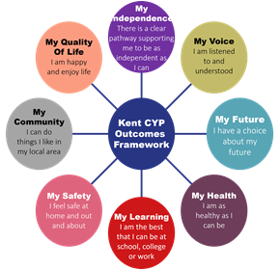

If you want to know more about our arrangements for SEND, read our SEND policy alongside this Information Report.
You can find our SEND policy on our website: https://greatstoneschool.co.uk/special-educational-needs/

Note: If there are any terms we’ve used in this information report that you’re unsure of, you can look them up in the Glossary at the end of the report.

What types of SEND does the school provide for?
Our school provides for pupils with the following needs (as outlined in the SEND Code of Practice 2015):

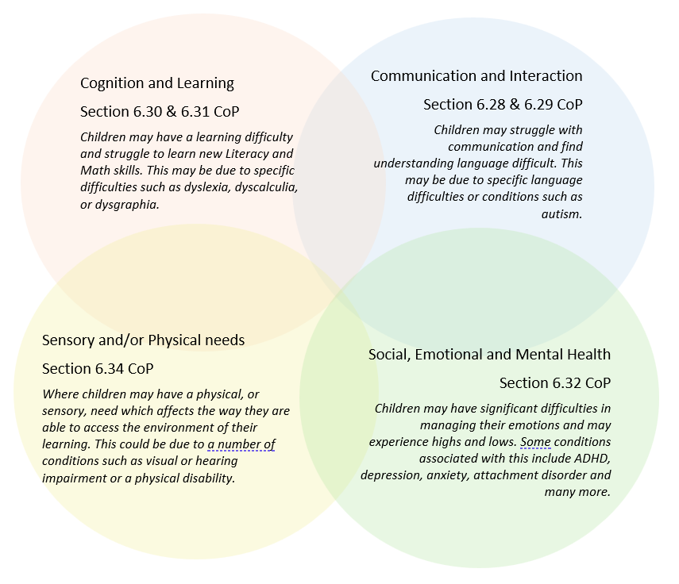

Often you will find that children’s needs overlap and are rarely confined to one area of need, which is why it is important to gain a holistic overview of your child.
More information about the Areas of Need can be found in the Special educational needs and disability code of practice: 0 to 25 years (link below).
SEND_Code_of_Practice_January_2015.pdf (publishing.service.gov.uk)

2. Which staff will support my child, and what are their key responsibilities?


At Greatstone Primary School all staff are considered responsible for supporting the needs of pupils with SEND. Our staff are committed to regular, high-quality training to ensure that they have the knowledge and skills to better meet a wide range of pupil needs.
Fiona Roberts is our Deputy Headteacher and SENCO. Louise Harman is our SENCO Assistant. Hannah Ferris is our Safeguarding and Pastoral Director and she is supported by Kelly Heath our Pastoral Assistant. Your child’s class teacher and TA are directly responsible for supporting your child day to day in the classroom. Please note that this list is not exhaustive

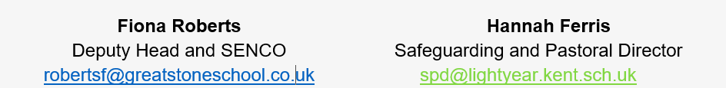

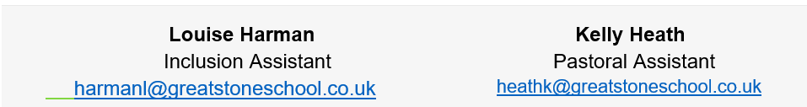

Our Special Educational Needs Co-ordinator, or SENCO
The named SENCO is Fiona Roberts.
She is a qualified teacher, Deputy Headteacher and is completing the National Professional Qualification for SENCOs.

Class/subject teachers
All of our teachers receive in-house SEND training, and are supported by the Inclusion Team to meet the needs of pupils who have SEND.
All school leaders, teachers and teaching assistants have awareness training for the main four areas of needs as part of a rolling programme and as part of their continued professional development. Some recent training includes:
Communication and Interaction:
- Language through Colour training
- Speech, Language and Communication Needs
- Autism

Cognition and Learning:
- Clicker Training
- Dyslexia Awareness training
- Metacognition

Social, Emotional and Mental Health:
- Team Teach (Senior Leaders and Pastoral Team)
- De-escalation strategies and Emotion Coaching
- Nurture Principles
- Attachment Awareness Training
- Boxall Profile

Sensory and Physical
- Diabetes Training
- Training in individual Occupational Therapy programmes

Some individual staff members are trained in:
- Senior mental Health Lead
- Drawing and Talking

Teaching assistants (TAs)
We have a team of teaching assistants, including an Inclusion teaching assistant and a SENCO Assistant who are trained to deliver SEN provision.
Our teaching assistants are trained to deliver interventions such as; Speech and Language therapy programmes, Precision Teaching, Sensory Circuits, Zones of Regulation, Fizzy, Clever Hands, Lego Play, Social Skills, Occupational therapy and many other bespoke interventions.
External agencies

Sometimes we need extra help to offer our pupils the support that they need. Whenever necessary we will work with external support services to meet the needs of our pupils with SEND and to support their families. These may include:

Specialist Teaching and Learning Service (STLS)
Educational psychologists
NHS Speech and Language Therapists
NHS Occupational Therapists
NHS Physiotherapists
SEND Inclusion Advisor
GPs or paediatricians
Early Help and Family Services
NELFT practitioners

Therapeutic practitioners
Safeguarding services
School Liaison Officer
School nurses
SEND Inclusion Advisor

Voluntary sector organisation

3. What should I do if I think my child has SEND?

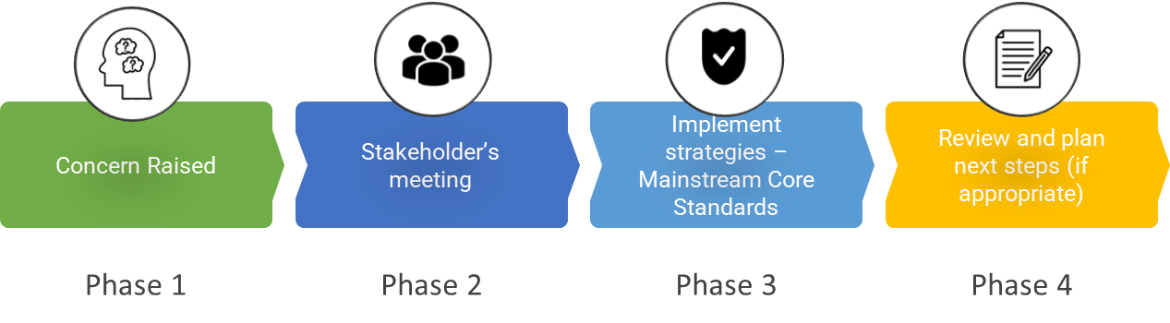

Phase 1 | If you think your child might have SEND, raise your concern with the school so that the SENCO is aware. Speak to your child’s class teacher or contact the Inclusion Team on robertsf@greatstoneschool.co.uk or 01797 363916
Phase 2 | We will meet with you to discuss your concerns and try to get a better understanding of what your child’s strengths and difficulties are. Together we will decide what outcomes to seek for your child and agree on next steps. We will make a note of what’s been discussed and add this to your child’s record.
Phase 3 | We will implement the agreed strategies and monitor these over an agreed period of time. These are likely to be universal strategies set out in the mainstream core standards. A copy of this can be found here:  https://www.kelsi.org.uk/__data/assets/pdf_file/0005/117257/Special-educational-needs-mainstream-core-standards-guide-for-parents.pdf  This will initiate the ‘Graduated Approach’ where support will be continually reviewed. See next page for more details.
Phase 4 | If we decide that your child needs SEND support, we will formally notify you and your child will be added to the school’s SEND register. They will receive additional support and this will be reviewed using the assess, plan, do, review model.

4. What happens if the school identifies a need?
The same process is followed if a concern is raised by the school.

All our class teachers are responsible for the monitoring of all pupils who have been identified as having SEND. They also review those who are not making the expected level of progress in their schoolwork or socially. This might include phonics, reading comprehensions, spelling, writing, arithmetic skills and mathematical reasoning.
If the teacher notices that a pupil is having difficulties, they try to find out if the pupil has any gaps in their learning. If they can find a gap, the school will provide appropriate support. Pupils who do not have SEND usually make progress quickly once the gap in their learning has been filled.
If the pupil is still finding it difficult to make the expected progress, the teacher will talk to the SENCO, and will contact you to discuss the possibility that your child has SEND, and the school will follow the graduated approach.

5. How will the school measure my child’s progress?
We follow the ‘graduated approach’ to meeting your child’s SEND needs.
The graduated approach is a 4-part cycle of assess, plan, do, review.
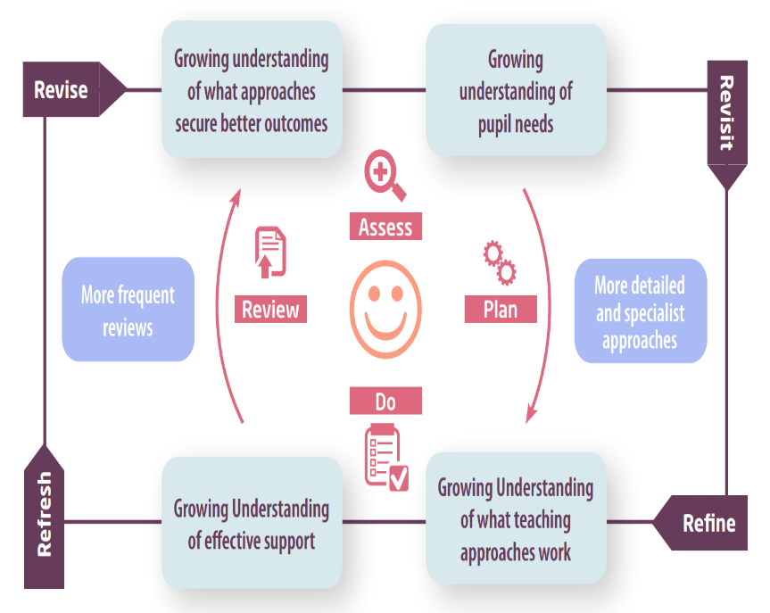

Assess | If your child is not making the expected level of progress, we will make an assessment to find out what strengths and difficulties your child has. We will ask for you and your child’s input, as well as getting help from external professionals where necessary.
Plan | In discussion with you and your child, we will decide what outcomes we are hoping to achieve. We will create a plan of the support that we will offer your child to help them meet those outcomes. We will make a record of this and share it with you and all relevant school staff.
Do | We will put our plan into practice.  The class teacher, with the support of the SENCO, will be responsible for working with your child on a daily basis, and making sure the support we put in place is having the impact we intended.
Review | We will assess how well the support we put in place helped the pupil to meet the outcomes we set. We will use our improved understanding of your child’s needs to improve the support we offer; this may mean the Plan, Assess, Do, Review cycle continues.
Teachers review progress within lessons through live marking and mini plenaries. Teachers and SLT, including the SENCO, assess pupils progress 3 times a year through pupil progress meetings. The class teacher and SENCO will review progress against small step SEND targets and SEND outcomes 3 times yearly and will involve parents in these discussions.
The school follows an assessment timetable which allows teaches to measure academic progress. Where these measures are not small enough, teachers will use small step trackers to measure progress.

6. How will I be involved in decisions made about my child’s education?
We will provide reports on your child's progress three times a year, in addition to parent/ teacher consultation meetings.
A member of staff who knows your child well will offer you the opportunity to meet three times a year to:
- Set clear outcomes for your child’s progress
- Review progress towards those outcomes
- Discuss the support we will put in place to help your child make that progress
- Identify what we will do, what we will ask you to do, and what we will ask your child to do

A member of the Inclusion Team may also attend these meetings to provide extra support.
We know that you’re the expert when it comes to your child’s needs and aspirations. So, we want to make sure you have a full understanding of how we’re trying to meet your child’s needs, so that you can provide insight into what you think would work best for your child.
We also want to hear from you as much as possible so that we can build a better picture of how the SEND support we are providing is impacting your child outside of school. If your child’s needs or aspirations change at any time, please let us know right away so we can keep our provision as relevant as possible.
If you have concerns that arise between these meetings, please contact your child’s class teacher or SENCO, who can be contacted on 01797 363916 or via the school office.

7. How will my child be involved in decisions made about their education?
The level of involvement will depend on your child’s age and individual needs. We recognise that no two pupils are the same, so we will decide on a case-by-case basis, with your input.
We may seek your child’s views by asking them to:
- Attend meetings to discuss their progress and outcomes
- Prepare a presentation or written statement
- Discuss their views with a member of staff who can act as a representative during the meeting
- Complete a survey
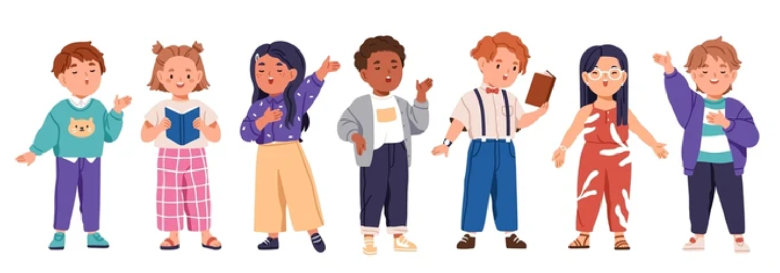
- For pupils with very complex needs we may share photos and observations from home and school

8. How will the school adapt its teaching for my child?
Your child’s class teacher is responsible and accountable for the progress and development of all pupils in their class. The first step in responding to your child’s needs is to ensure high quality teaching and that they have access to a broad and balanced curriculum.
We will adapt our approaches to how we teach to suit the way the pupil works best. There is no 'one size fits all’ approach to adapting the curriculum, we work on a case-by case basis to make sure the adaptations we make are meaningful to your child and are guided by the Mainstream Core Standards in the first instance.

These adaptations may include:
- Adapting our approaches, for example, giving longer processing times, pre-teaching of key vocabulary, reading instructions aloud, etc.

- Adapting our resources and staffing. Pupils may require additional resources such as access to visual supports e.g. word banks, writing frames, planning tools, Clicker to support with the mechanics of writing etc.

- Using recommended aids, such as laptops, coloured overlays, visual timetables, larger font, etc.

- Teaching assistants or support staff will support pupils appropriately depending on their presentation of need

- Scaffolding lesson materials through the use of In Print and Widgit Symbols reducing cognitive load

- Supporting children who use alternative communication methods, using a total communication approach such as Makaton or communication books/ boards to be able to access learning.

- All classrooms have a calm space and access to safe spaces around the school to support learners that require low arousal environments to support their access to the classroom/ curriculum.

We may also provide the following interventions:
Communication and Interaction (C&I) | Cognition and Learning (C&L) | Social, Emotional and Mental Health (SEMH) | Sensory and Physical (S&P)
Speech Link  Language Link  Language Through Colour  Lego Play  Individual speech and language therapy programmes (as advised)  Social Stories | Literacy Gold  Number Stacks  Precision Teaching  Phonics Interventions  Pre-Teaching  Use of Clicker  Toe by Toe  Number Box | Zones of Regulation  Emotional Literacy Support  Nurture Group  Nurture Breakfast Club  Lunch Club  Social Skills  Drawing and Talking | Sensory Circuits  Beam  Clever Hands  Fizzy  Handwriting Interventions  Occupational Therapy Programmes (as advised)

These interventions are part of our contribution to Kent County Council’s local offer.

9. How will the school evaluate whether the support in place is helping my child?
Reviews of the SEN support will be informed by assessment information from teachers which will show whether adequate progress is being made, in addition to the views of the pupil, parents and other adults supporting the child’s learning.
Every pupil in the school has their progress reviewed at least three times per year. In addition to this, pupils with special educational needs may have additional assessments undertaken by school staff or external professionals in order to evaluate the effectiveness of the provision. The effectiveness of provision may be evaluated from a review of records and tracking systems. If these assessments do not show adequate progress is being made, the SEN support will be reviewed and adjusted. Additional external advice may be sought through the Local Inclusion Forum Team (LIFT) with parental consent. For pupils with an Education, Health and Care Plan there will also be an annual review of the provision made for the child, which will enable an evaluation of the effectiveness of the additional provision.

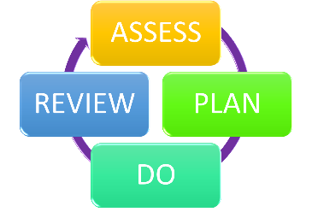
We will evaluate the effectiveness of provision for your child by:
- Reviewing their progress towards their goals or targets each term
- Reviewing the impact of interventions after 6-8 weeks or as the intervention is completed.
- Seeking pupil voice through face-to-face conversations or through pupil questionnaires.
- Monitoring by the Inclusion Team/ Leadership Team
- Using provision maps and personalised plans to measure progress
- Holding an annual review (if they have an education, health and care (EHC) plan)

10. How will the school ensure my child has appropriate resources?
As part of our budget we receive ‘notional SEN funding’. This funding is used to ensure that the quality of teaching is at least good in the school and that there are sufficient resources to deploy additional and different teaching for pupils requiring SEND support. The amount of support that a pupil requires to make good progress, will be different in every case. In some cases, a very high level of provision may be required in order for a child to make good progress. The funding arrangements require schools to provide up to £6000 per pupil with high needs per annum, and above that amount the Local Authority should provide top up to the school.
It may be that your child’s needs mean we need to provide additional resources such as:
• Additional resources to support their learning
• Adaptations to in class support
• Further training for our staff
• External specialist expertise
Where appropriate, we will consult with external agencies to get recommendations on what will best help your child access their learning and use our best endeavours to ensure these are supplied.

11. How will the school make sure my child is included in activities alongside pupils who don’t have SEND?


All clubs, trips and activities offered are available to all pupils with special educational needs either with or without an Education, Health and Care Plan. Where it is necessary, the school will use the resources available to it to provide additional adult support to enable the safe participation of the pupil in the activity. The school will make appropriate arrangements and adaptions in agreement with parents, to ensure that the individual needs of the child are met and that they are able to access trips fully, including residential trips.
All of our extra-curricular activities and school visits are available to all our pupils, including our before and after-school clubs.
All pupils are encouraged to go on our school trips, including a residential trip for Year 4 and Year 6. If the child or parent does not wish to access a school trip or residential, an alternative in school activity will be made available.
All pupils are encouraged to take part in class assemblies, sports day, school performances and class workshops.
No pupil is ever excluded from taking part in these activities because of their SEN or disability and we will make whatever reasonable adjustments are needed to make sure that they can be included.

12. How does the school make sure the admissions process is fair for pupils with SEN or a disability?
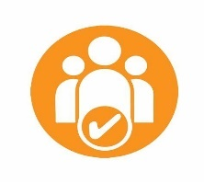

Greatstone Primary School is a Foundation School and so the Governing Body is the admissions authority. However, the Governors of Greatstone Primary School will work in co-operation with Kent County Council in order to operate within the Local Authority’s Co-ordinated Scheme for Primary Admissions. For Reception aged children the school’s Published Admission Number (PAN) is 30
- Children with an Education Health Care Plan (EHCP);
- Children in, or previously in, the care of the Local Authority;
- Current Family Association (Sibling in the school at the time of entry);
- Health and Special Access Reasons;
- Children of Staff at the school (employed for 2 or more years/ demonstrated skill shortage);
- Proximity of the child’s home address to the school;
In Year Casual Admissions are admissions which take place outside of the normal entry to school. AN IYCAF (In Year Common Application Form) needs to be completed and returned to the school. If a place is not available the school will contact the family to explain this and place the child on to our waiting list.
Where a prospective pupil has a special educational need or disability, the SENCO or a member of the Inclusion Team will work closely with the child’s family to ensure that they are well supported when they start school.
For further information please refer to our Admissions Policy.

13. How does the school support pupils with disabilities?


The Equality Act 2010 defines disability as a physical or mental impairment that has a ‘substantial’ and ‘long-term’ negative effect on a person’s ability to do normal daily activities.
Children with disabilities in our school are supported to access the curriculum and school environment in a number of ways, including through the use of physical aids, visual aid and the delivery of therapy programmes. Where required, we also support pupils with SEN and disabilities through individualised reasonable adjustments which are made to ensure that they are able to dully access and participate in whole-school community.
For further information please refer to our school website regarding Inclusion, where you can access our Accessibility Policy and Equality and Diversity Plan.

14. How will the school support my child’s mental health and emotional and social development?
At Greatstone Primary School, we strive to be a place of nurture for the children; the basis of our school is built upon the relationships we have with the children and families, which will allow them to be successful. Greatstone Primary School is working towards being recognised as a Nurturing School. A whole school approach is considered the best way to support our children, everybody’s wellbeing is important and needs to be nurtured.
Children and young people can be faced with difficulties at school or home which, as well as affecting their emotional wellbeing and social skills, create barriers to learning. To unlock pupils’ potential, we provide them with the support they need to feel safe at school, to be able to get on with other children, and develop the confidence and resilience they need to succeed both academically and in life. The nurturing approach is underpinned by Quality First Teaching and promotes healthy outcomes for children by responding to their emotional needs. Children develop vital social skills, to develop confidence and self-respect, and to take pride in behaving well and in achieving.
We assess our children's social, emotional and mental development using the Boxall Profile - the tool provides a precise picture of a child’s strengths, as well as any difficulties which could affect their learning.
We provide support for pupils to progress in their emotional and social development in the following ways:
- Pupils with SEND are encouraged to be part of the school council
- Pupils with SEND are also encouraged to be part of a range of clubs to promote teamwork/building friendships
- We provide extra pastoral support for listening to the views of pupils with SEND by using pupil surveys and informal check-ins
- We run a Nurture Breakfast club and Lunch Club for pupils who need extra support with social or emotional development
- We have a ‘zero tolerance’ approach to bullying. We prevent bullying in the school by working closely with children, staff and families to raise awareness of bullying, identifying and addressing concerns in a timely manner; providing additional support and reassurance, where appropriate. Out processes and procedures can be found in our Anti-Bullying Policy.

15. What support is in place for looked-after and previously looked-after children with SEND?


Mrs Ferris, our Safeguarding and Pastoral Director is the designated teacher for looked-after children and previously looked-after children here.
Mrs Ferris will work with Mrs Roberts, our SENCO, to make sure that all teachers understand how a looked-after or previously looked-after pupil’s circumstances and their SEND might interact, and what the implications are for teaching and learning.
Pupils who are looked-after or previously looked-after will be supported much in the same way as any other child who has SEND. However, looked-after pupils will also have a personal education plan (PEP). We will make sure that the PEP and any SEND support plans or EHC plans are consistent and complement one another.

16. What support will be available for my child as they transition between classes or settings or in preparing for adulthood?
Transitions are an important part of a child’s day/ life and it is fundamental that these are well planned for so that children can be prepared for any changes. We ensure that transitions are managed appropriately e.g. between home and school, between sessions, different adults etc. Changes in routine can be difficult for children and need to be carefully managed with preparation and support. We have additional support for children who find transitions particularly difficult.
Below are some of the steps that we take as a school to support children will transitions that are fundamental changed to their educational journey.

Transition from Pre-School to Primary School
The class teacher and/ or the SENCO will meet with your child’s keyworker/ SENCO and with you, to find out more about their needs and to plan for their transition to school. They will liaise with any other professionals supporting you or your child and make sure that any support that your child needs is in place ready for them when they start at the school.

Typically, all children and their families will receive a home visit and a nursery visit, along with being invited to transition events such as; stay and play sessions. All families will be invited to a welcome evening, where there is an opportunity to speak to the Inclusion Team. Where appropriate and deemed necessary additional transition activities can be arranged. All children will be provided with a transition book with key photos and information that may be useful to support your child with transitioning in to Reception.
Between years
At Greatstone Primary School all children participate in transition days in Term 6 to support with the transition between year groups. To help pupils with SEND be prepared for a new school year we:
- Ask both the current teacher and the next year’s teacher to attend final meeting of the year when the pupil’s SEND is discussed
- Social Stories and visuals
- Opportunities to build relationships and share learning with any new adults that will be in the child’s new year group
- Where appropriate, additional transition meetings between the class teacher and parents
Between phases (Transitioning to Secondary School)
The SENCO of the secondary school will come into our school for a meeting with our SENCO. They will discuss the needs of all the pupils who are receiving SEND support.
Pupils will be prepared for the transition by:
- Engaging in ‘Sixth Form’, where all children have the opportunity to practise with a timetable moving between classrooms and collecting books and resources for each lesson.
- Engaging in transition days organised by the receiving school. Additional transition sessions can be requested where appropriate.
- Engaging in PSHE lessons linked to transition and preparing for change
- Plugging any gaps in knowledge
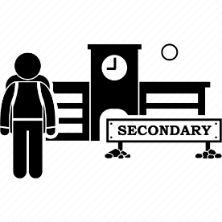

Between schools
When your child is moving on from our school, we will ask you and your child what information you want us to share with the new setting.
Where appropriate, the school will support the transition with liaising with the receiving schools SENCO to ensure a detailed handover has been completed.


17. What support is available for me and my family?
If you have questions about SEND, or are struggling to cope, please get in touch to let us know. We want to support you, your child and your family.
The Children and Families Act 2015 requires the Local Authority (LA) and schools to publish and keep under review information about services they expect to be available for children and young people with special educational needs and disabilities (SEND) aged 0-25. The LA refer to this as the 'Local Offer'. To see what support is available to you locally, have a look at your local authority’s (Kent) local offer. Kent publishes information about the local offer on their website:
https://www.kent.gov.uk/education-and-children/special-educational-needs
About the special educational needs and disabilities (SEND) local offer – Kent County Council
Our local special educational needs and disabilities information advice and support services (SENDIASS) organisations are:
IASK (Information and Support Kent) and their website is:
https://local.kent.gov.uk/kb5/kent/directory/service.page?id=q8eJOMCAQOI&localofferchannel=2
Kent Family Hub offer support and activities for families with a range of needs. Your local family hub can be found here: https://www.kent.gov.uk/education-and-children/kent-family-hub/your-local-family-hub

National charities that offer information and support to families of pupils with SEND are:
- IPSEA
- SEND family support
- NSPCC
- Family Action
- Special Needs Jungle

18. What should I do if I have a complaint about my child’s SEND support?
If you have a complaint about the provision made for your child, we encourage parents to discuss their concerns with the SENCO or Headteacher in the first instance. They will then be referred to the school’s complaints policy: Complaints Policy
If you are not satisfied with the school’s response, you can escalate the complaint. In some circumstances, this right also applies to the pupil themselves.
There are some circumstances, usually for children who have an EHC Plan where there is a statutory right for parents to appeal against a decision of the Local Authority. Complaints which fall within this category cannot be investigated by the school.
To see a full explanation of suitable avenues for complaint, see pages 246 and 247 of the SEND Code of Practice.
If you feel that our school discriminated against your child because of their SEND, you have the right to make a discrimination claim to the first-tier SEND tribunal. To find out how to make such a claim, you should visit: https://www.gov.uk/complain-about-school/disability-discrimination
You can make a claim about alleged discrimination regarding:
- Admission
- Exclusion
- Provision of education and associated services
- Making reasonable adjustments, including the provision of auxiliary aids and services
Before going to a SEND tribunal, you can go through processes called disagreement resolution or mediation, where you try to resolve your disagreement before it reaches the tribunal.
Mediation support and appeals – Kent County Council

19. Supporting documents

- Equality Information and Objectives Policy
- Child protection and safeguarding policy
- Behaviour Policy
- Accessibility Plan
- Attendance and punctuality policy
- SEND policy
- SEN & Disabilities Code of Practice 2015
- Mainstream Core Standards

20. Glossary
- Access arrangements – special arrangements to allow pupils with SEND to access assessments or exams
- Annual review – an annual meeting to review the provision in a pupil’s EHC plan
- Area of need – the 4 areas of need describe different types of needs a pupil with SEND can have. The 4 areas are communication and interaction; cognition and learning; physical and/or sensory; and social, emotional and mental health needs.
- CAMHS – child and adolescent mental health services
- Differentiation – when teachers adapt how they teach in response to a pupil’s needs
- EHC needs assessment – the needs assessment is the first step on the way to securing an EHC plan. The local authority will do an assessment to decide whether a child needs an EHC plan.
- EHC plan – an education, health and care plan is a legally-binding document that sets out a child’s needs and the provision that will be put in place to meet their needs.
- First-tier tribunal/SEND tribunal – a court where you can appeal against the local authority’s decisions about EHC needs assessments or plans and against discrimination by a school or local authority due to SEND
- Graduated approach – an approach to providing SEND support in which the school provides support in successive cycles of assessing the pupil’s needs, planning the provision, implementing the plan, and reviewing the impact of the action on the pupil
- Intervention – a short-term, targeted approach to teaching a pupil with a specific outcome in mind
- Local offer – information provided by the local authority which explains what services and support are on offer for pupils with SEND in the local area
- Outcome – target for improvement for pupils with SEND. These targets don't necessarily have to be related to academic attainment
- Reasonable adjustments – changes that the school must make to remove or reduce any disadvantages caused by a child’s disability
- SENCO – the special educational needs co-ordinator
- SEN – special educational needs
- SEND – special educational needs and disabilities
- SEND Code of Practice – the statutory guidance that schools must follow to support pupils with SEND
- SEND information report – a report that schools must publish on their website, that explains how the school supports pupils with SEND
- SEND support – special educational provision which meets the needs of pupils with SEND
- Transition – when a pupil moves between years, phases, schools or institutions or life stages

